**Risk-based evaluations of competing agronomic climate adaptation strategies: The case of rice planting strategies in the Indo Gangetic Plains**

Maxwell Mkdondiwa,1 Anton Urfels2,3

1 CIMMYT International Maize and Wheat Improvement Center, New Delhi, India

2 International Rice Research Institute (IRRI), Los Baños, The Philippines

3 Water Resources Management Group, Wageningen University & Research, Wageningen, NL

# Abstract

CONTEXT: Adjusting crop planting dates and variety durations is emerging as a crucial climate change adaptation strategy for many cereal systems. Such strategies include, for example, harmonizing crop planting with the onset of the rainy season or planting at specific recommended calendar dates. Evaluations of these strategies mostly consider yield and yield variability, but focus less on financial risks associated with different planting strategies. However, choosing recommendations amongst competing levels of yield and yield stability is not straightforward and need to cater to farmers that are mostly risk averse.

OBJECTIVE: Here, we present a novel framework that uses a computational spatial exante approach for risk-based evaluations of agronomic adaptation options.

METHODS: To demonstrate our approach, we compare the risks associated with readily available gridded crop simulation outputs for various rice planting strategies across the Indo-Gangetic Plains.

RESULTS AND CONCLUSIONS: Our findings provide quantitative evidence for where the previously recommended rice planting date strategies are less also less risky. Our risk-based assessment corroborates the recommendation for planting long-duration varieties at the monsoon onset in the Eastern IGP, and planting rice at state-recommended planting dates in most of the Western and Middle IGP. Importantly, our risk-based assessment shows where the results are not as clear cut – especially in the Middle IGP where farmers appear to have more flexibility to achieve comparable outcomes with several planting strategies.

SIGNIFICANCE: In conclusion, our approach provides a useful and novel tool for comparing different agronomic climate adaptation strategies from an economic risk perspective in a spatial framework.

# Graphical Abstract

# 

Rice planting strategies for risk averse farmers

**Keywords:** sustainable agriculture, spatial economics, climate resilience, irrigation, smallholder farmers

# 1. Introduction

Climate change is predicted to have a largely negative impact on the agricultural systems of low-income countries (IPCC, 2022). To adapt, farmers and policy makers must choose between several competing agronomic response options. Researchers usually evaluate these options based on average yield levels, water use, and income across years with varying weather conditions and provide subsequent recommendations. However, comparing these different indicators and assessing acceptable levels of variability is not straightforward resulting in recommendations based on qualitative expert judgement and mean comparisons that disregard downside risks. Using means for evaluation agronomic response options is especially inadequate for risk averse smallholder farmers that seek to minimize any losses they may have to incur. How, for example, shall one evaluate an adaptation strategy that, across several years, has been shown to require an average of 50mm additional water use to gain 300 kg of yield, 10% more income and increase yield variability by 5%?

Deriving recommendations for rice planting in the rice-wheat cropping systems of the Indo-Gangetic Plains (IGP) is a case in point. In the IGP, rice is planted in the monsoon season from June to October (also called kharif) while wheat is grown as an irrigated crop in winter season from November to April (also called rabi). Climate impacts on agricultural systems of the IGP are amongst the most severe globally (IPCC, 2022), as, e.g., late monsoon onsets delay rice sowing in the Eastern IGP and push wheat crops into periods of high terminal heat stress – while farmers in the Western IGP use free electricity to plant their rice crops early in the hot summer months and contribute to groundwater depletion. Recent compelling evidence (e.g., Wang et al 2023, Ishtiaque et al 2022, Newport et al 2020, McDonald et al 2022, Urfels et al 2021, Urfels et al 2022, and Montes et al 2022) suggests that advancing the planting date of rice to match the monsoon onset is one of the viable adaptation options for farmers in the Eastern IGP – and might help to alleviate groundwater depletion in the Western IGP. To test this hypothesis, Urfels et al (2022) and Montes et al (2022) used gridded crop simulations for the Indo-Gangetic Plains to investigate the impact of different rice planting strategies (combining sowing dates, variety duration and irrigation) on system level productivity, resilience, and environmental benefits. However, most farmers are risk averse and not only interested in long-term profit maximization and yield outcomes. It is thus important to consider economic risks and not just average yield and yield variability when evaluating agronomic adaptation strategies. For example, recent studies (see, Hurley et al 2018, Suri 2011) have shown that year to year variation in economic returns to adopting technologies can result in lower levels of adoption of generally profitable agricultural innovations – but approaches for evaluation agronomic strategies from a risk perspective remain scarce.

To address this knowledge gap, we deploy a robust and risk-oriented framework to select suitable adaptation strategies for risk-averse farmers. To demonstrate our approach, we evaluate the riskiness of adopting various rice planting strategies across the IGP by re-evaluating the results of crop the model simulations of various rice planting strategies across the IGP by Urfels et al. (2022).

This paper contributes to two strands of literature. The first strand of literature is on stability analyses of agricultural technology benefits based on ex-ante cropping system assessments (e.g., Urfels et al 2022, Montes et al 2022). Montes et al (2022) used inter-annual standard deviation to analyze the stability of the planting date scenarios. Urfels et al (2022) used deviation from the mean caloric yield for each of the years when a shock occurred as a measure of yield instability. These measures of yield stability while a step better than mean comparisons, they do not consider robustness of the optimal decision to risk aversion of the farmers. In addition, these measures do not consider higher order moments beyond mean and variability that may matter for distributional comparisons. In addition, we argue that stability analyses just as comparisons of means do not consider the trade-offs of achieving the highest returns with the lowest uncertainty. While uncertainty of modelling has been addressed by, for example, using model ensembles or monte carlo simulations, these only allow for stronger confidence in the mean and variation around it – but do not take into account farmers’ risk preferences.

These limitations are addressed in the second strand literature which focuses on the spatial risk assessment of economic benefits of agricultural innovations (e.g., Nalley and Barkley 2010, Hurley et al 2018). This literature attempts to optimize on the trade-offs of achieving the highest return and lowest uncertainty therefore allows one to choose strategies that are more robust. Using modern portfolio theory (Markowitz 1959) which suggests that a strategy to maximize average returns may be a suboptimal strategy, Nalley and Barkley (2010) used a mean-variance analysis to optimally select wheat varieties that achieve highest return and lowest risk. This strategy still suffers from the limitation of using a subset of moments (mean and variance) of the distribution. The stochastic dominance approach was developed to resolve these concerns in selecting robust strategies (Levy 2016). Using long term weather data, crop simulation model results (APSIM), spatially explicit observed maize prices, and fertilizer prices; Hurley et al (2018) simulates whether weather risk affects the adoption of fertilizer and improved maize seeds. They use heterogeneity in soils and climate in a calibrated crop growth model to simulate the distributions of yields across adoption of fertilizer and improved maize seed scenarios.

We specifically follow the approach proposed by Hurley et al (2018)[[1]](#footnote-2) to estimate willingness to pay bounds for a risk averse farmer to likely adopt an alternative rice planting date strategy. We depart from their approach in three substantial ways. First, instead of fertilizers and improved varieties, we consider multiple management changes including sowing dates, irrigation amounts, and varieties differing on duration to maturity. Second, we consider a rice-wheat multi-crop system unlike Hurley et al (2018) who focus on maize only. Third, we do not only consider pairwise comparisons but also use the willingness to pay bounds to select the best strategy among the multiple competing options. Our application shows how this risk-assessment framework can handle increasingly complex decisions.

The rest of the paper is organized as follows. We present next the methods focusing on the computational risk assessments. In section 3 we present results and discussion of the yield and economic benefits of alternative planting date strategies. We finally conclude in section 4.

# 2. Methods

In this section, we showcase and explain our risk-assessment framework. We first explain the framework from a theoretical perspective. Subsequently, we briefly explain how we use the gridded APSIM simulation outputs from Urfels et al. (2022) to illustrate our approach.

In short, we illustrate our approach in the Results section by (i) comparing the different planting strategies by crop and their yield risks, (ii) systems level revenue, and (iii) system level partial profits. Finally, (iv) we determine the most optimal planting strategy for risk averse farmers for each grid-cell across the IGP. To determine which strategy performs best from a risk perspective, we use a novel method to estimate willingness to pay bounds through a stochastic dominance approach to determine which rice planting strategies are both economically beneficial and least risky. To assess economic returns, we multiply the simulated yield outcomes with spatially explicit price data for rice and wheat. Since the only variable cost of in the simulation is irrigation amount, we consider their impact on the outputs and calculate partial profits using common irrigation cost of US$1.26 per m3 and multiply it with the total irrigation amount required in each simulation.

The remainder of this Methods section provides an overview of (i) our risk assessment approach and (ii) more details on the input data.



## 2.1. Computational spatial ex-ante economic model under risk aversion

Our framework uses a two-step approach, first evaluating systems-level yield risks and subsequently systems level economic risks. For both yield risks and economic risks, we assess adaptation options through a willingness to pay (WTP) lens that considers both economic performance and riskiness. The guiding question is: How much would a farmer be willing to pay for an adaptation option and still be clearly better off than with the baseline? To assess this, we assume that an adaptation option is suitable for risk averse farmers if the distribution (not just the average) of yield and economic outcomes supersedes the baseline. Using the so called ‘second order stochastic dominance’ (SOSD) – a well-established measure in decision theory for comparing the riskiness inherent in two distributions – we assess whether the adaptation option is less risky than the baseline (i.e. negative outcomes less likely).Below we provide an overview of how SOSD works for our case. For more details regarding SOSD and risk aversion, please see Levy (2016) and Meyer (1977) for a detailed explanation.

### 2.2. Comparing the riskiness of two agronomic adaptation options

To evaluate the riskiness of an adaptation option regarding either yield or economic returns, we compute spatially explicit willingness to pay bounds in rice and wheat yield equivalents that define, for a risk averse farmer, whether that farmer would adopt a technology or not. While SOSD provides an estimate of which option is risker – we use Hurley et al.’s (2018) approach to further assess how much better it is. In principle, the WTP bounds indicate (i) how much the cumulative distribution of the adaptation option can be shifted to the left (i.e. the benefits uniformly reduced) and still outperform the baseline (lower bound), and (ii) how much the cumulative distribution function can be moved to the right (i.e. the benefits uniformly increased) before it is entirely on the right side of the baseline (upper bound).

To demonstrate this approach,

we use a hypothetical experiment shown in Figure 1. Based on mean comparisons, $G$ is clearly better than $F$ and $Q$. If we think in terms of distributional differences, $G$ is clearly better than $Q$ because the cumulative distribution curve of $G$ is wholly to the right of $Q$. This is also called first order stochastic dominance. Consider the next case, where $G$ and $F$ are having crossing cumulative distribution functions. Visually, it can be assessed that $G$ has a higher mean and much lower likelihood of low performing outcomes. G has a higher mean and is less risk. This is, G second order stochastically dominates $F$. Since the cumulative distribution function of G and F are crossing each other, neither distribution first order stochastically dominates the other.

Lastly, consider the case of $F$ and $Q$, they are crossing each other and have the same mean. It is difficult to visually assess which one is more risky – i.e. determine the second order stochastic dominance ordering for these technologies.

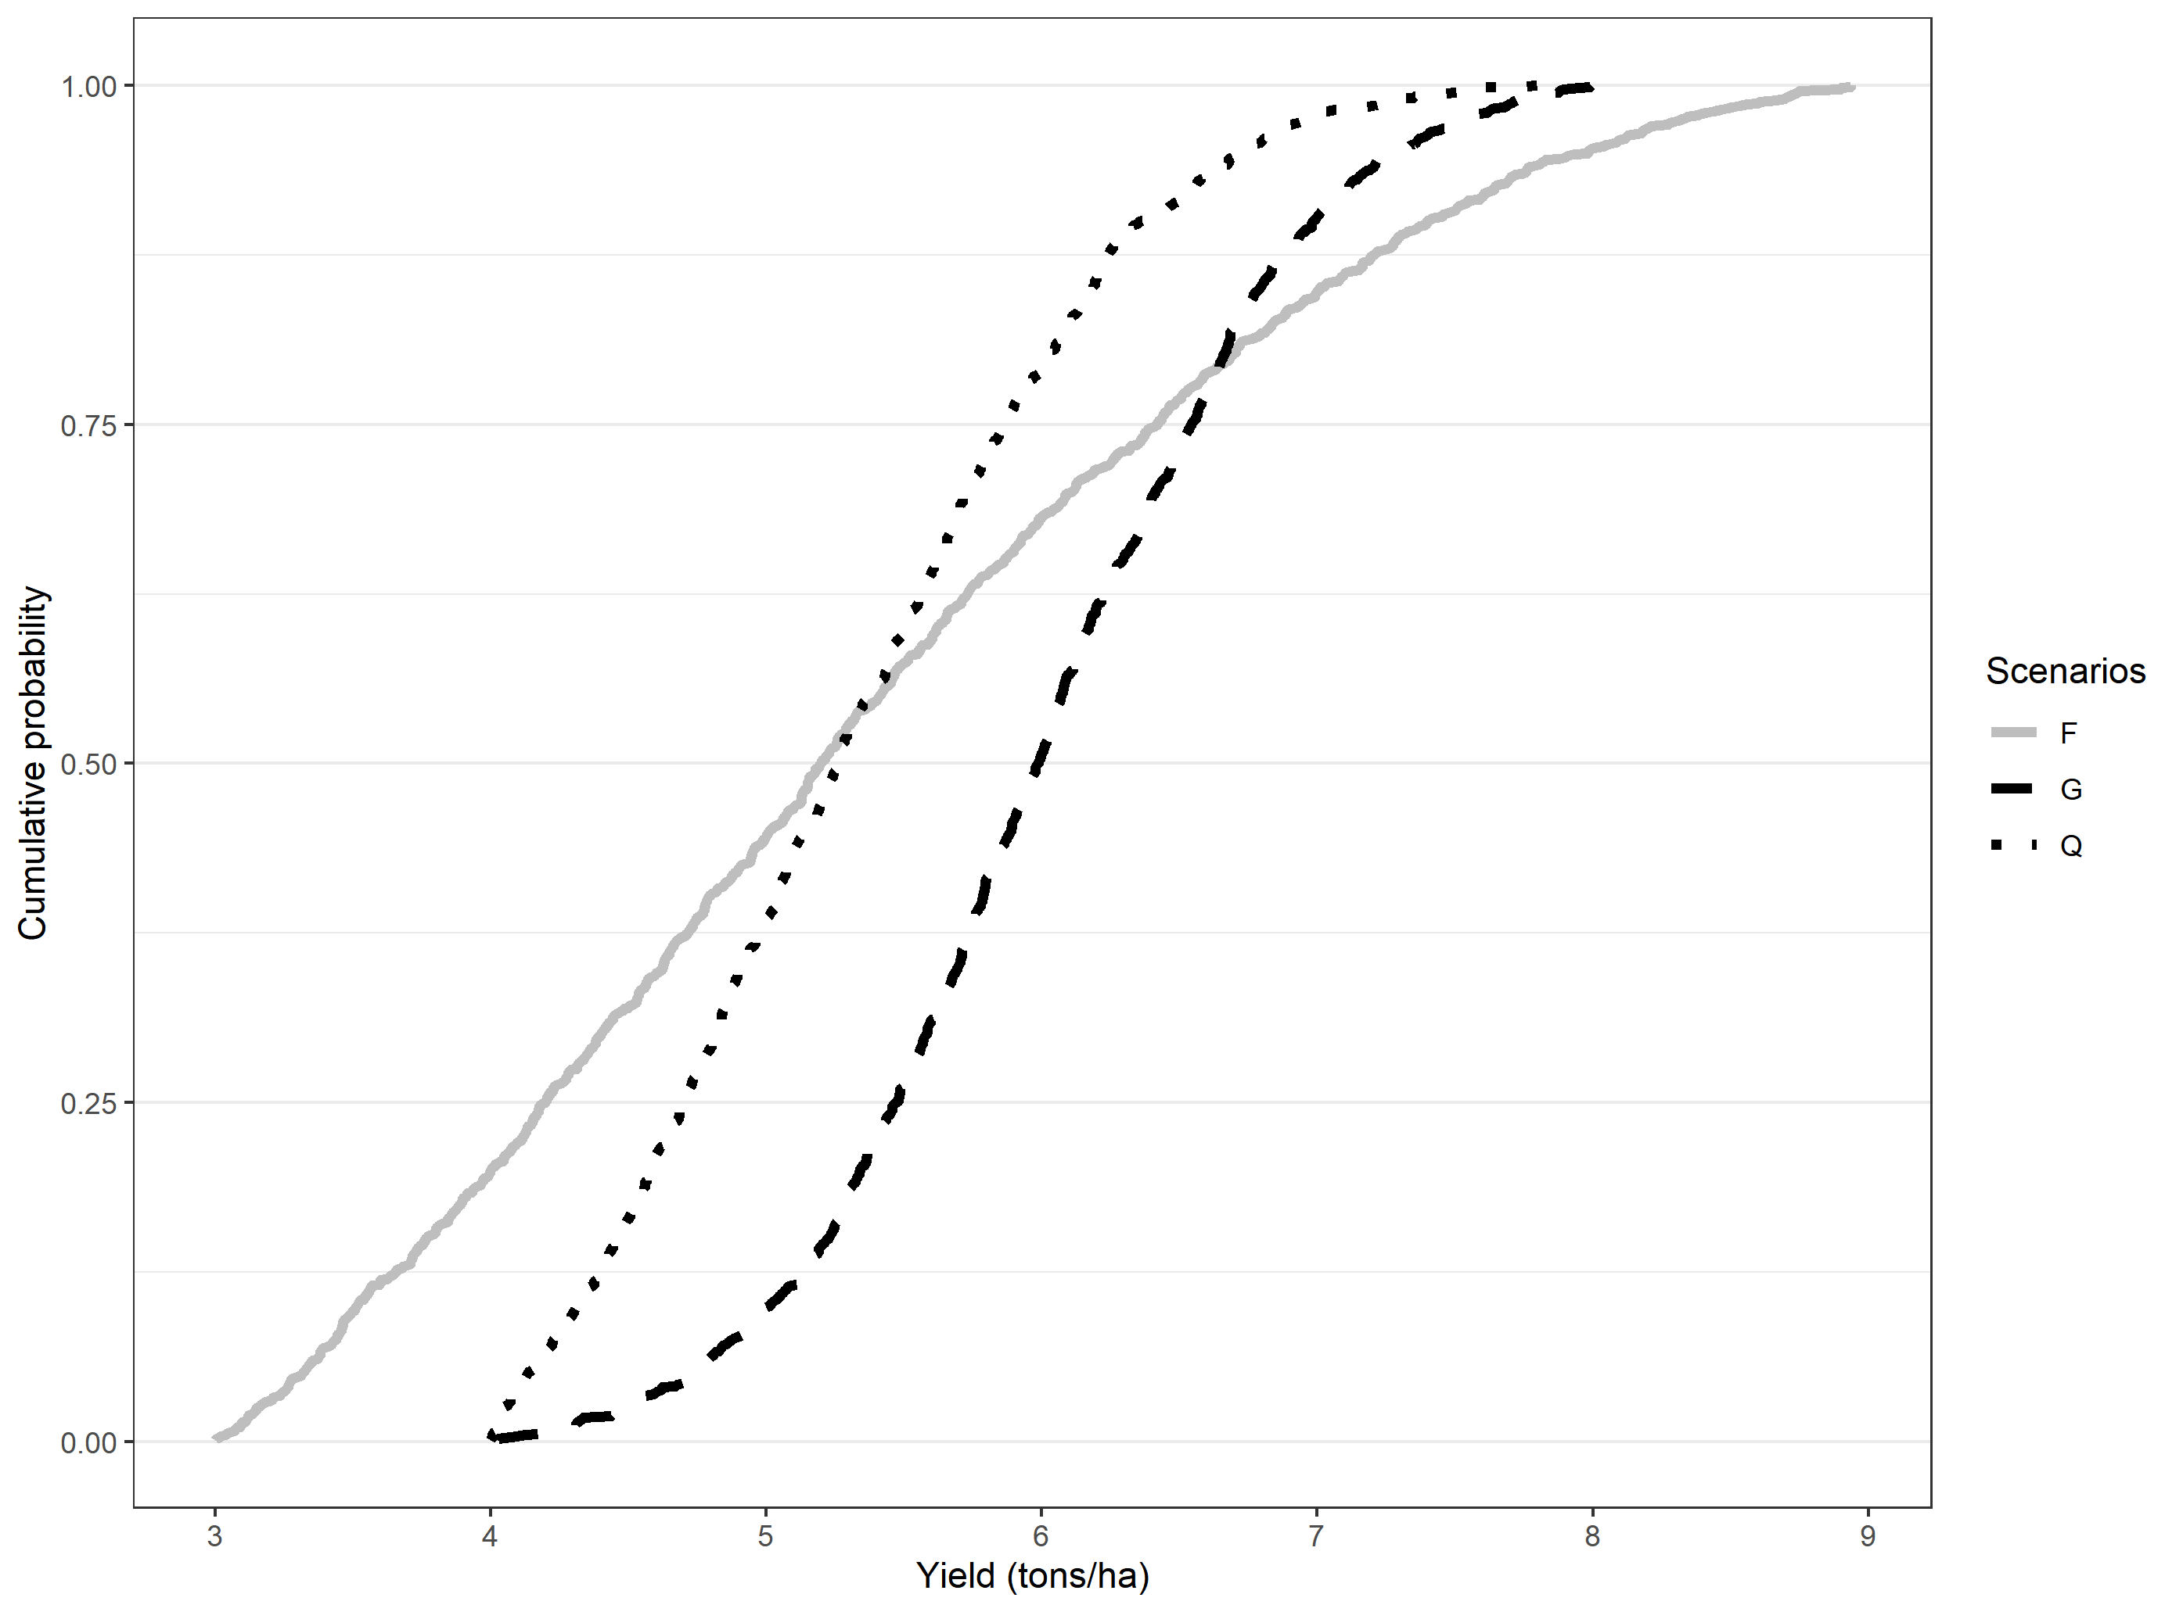

Figure 1: Hypothetical stochastic dominance assessment

***Note:*** We use a truncated normal distribution with four parameters: minimum (a), maximum (b), mean, and standard deviation (sd). The parameters used for each of the scenarios are as follows: G= rtruncnorm (n=1000,a=4,b=8, mean=6,sd=0.8), Q=rtruncnorm (n=1000,a=4,b=8, mean=5,sd=1), F=rtruncnorm (n=1000,a=3,b=9, mean=5,sd=2).

The lower WTP bound that makes any risk-averse farmer prefer new technology (in this case scenarios other than the baseline) can be derived using second order stochastic dominance (see Hurley et al 2018 for detailed derivations). If both lower bound and upper bound are positive, then any risk averse farmer will prefer the new technology. Conversely, if both lower bound and upper bound are negative, then any risk averse farmer will stick to the old technology. If however, the lower bound is negative and the upper bound is positive, then it is requires an explicit understanding of risk preferences—information not easily available—to determine which distribution is preferred. We use Octave for the computational analyses.

Proceeding with the hypothetical distributions, we show in table 2 results from using our approach to compute upper and lower willingness to pay bounds. The WTP bounds are positive for the comparison between Q and G as well as F and G.

Table 2: Hypothetical distributions and willingness to pay bounds

|  |  |  |  |
| --- | --- | --- | --- |
| Panel (a): Truncated normal distribution parameters for the hypothetical distributions | | | |
| Truncated normal parameters | G | Q | F |
| N | 1000 | 1000 | 1000 |
| Min=a | 4 | 4 | 3 |
| Max=b | 8 | 8 | 9 |
| Mean | 6 | 5 | 5 |
| SD | 0.8 | 1 | 2 |
| **Panel (b): Willingness to pay bounds from computational second order stochastic dominance assessment** | | | |
|  | Q(base)  vs G | Q vs F | F vs G |
| WTP lower bound (t/ha) | 0.036 | 0 | 0.499 |
| WTP upper bound (t/ha) | 0.763 | 0.218 | 1.384 |
| Interpretation | G F/SOSD Q | Not clear | G SOSD F |

The sign for the WTP bounds gives the evaluation of the benefits of the technology for a risk averse farmer. If both upper and lower bounds are positive, the farmer is willing to pay for that strategy. The upper bound is the amount of money that would pay just to stay with the new technology and thus abandon because it is second order stochastically dominated, while the lower bound is the amount that would pay just to be indifferent between the new strategy and the base strategy. For negative WTP for upper and lower bound, it shows that they would need to be paid to accept the proposed strategy. Lower bound is the amount of money that they would accept to abandon their existing strategy. Upper bound is the amount of money that they would accept just to be indifferent between the new strategy and their existing strategy.

## 2.3. APSIM spatially gridded crop model scenarios

The data used in this paper was based on gridded APSIM crop growth simulation model results for climate variables for the period 1982-2015 reported in Urfels et al (2022) and Montes et al (2022).[[2]](#footnote-4). We use seven scenarios from crop simulation results reported in Urfels et al (2022). The scenarios correspond to variation in irrigation, varietal duration and the planting of rice at the onset of the monsoon. Table 1 shows the details for the scenarios.

Table 1: Scenarios

|  |  |  |
| --- | --- | --- |
| Scenario number | Rice planting strategy | Description |
| S0 | Farmer practice | Farmers’ practice baseline without nutrient and water limitations to understand current limits |
| S1 | Fixed long (baseline) | Planting long duration variety at a fixed recommended date (state recommendation) |
| S2 | Fixed medium | Planting medium duration variety at a fixed recommended date |
| S3 | Onset long | Planting long duration rice variety at the onset of monsoon |
| S4 | Onset long supp | Only providing supplementary irrigation for planting long duration varieties at monsoon onset |
| S5 | Onset medium | Planting medium duration variety at monsoon onset |
| S6 | Onset medium supp | Supplementary irrigation for planting medium varieties at monsoon onset |

We supplement the APSIM model results with spatially gridded rice and wheat prices from the Landscape Crop Assessment Survey (LCAS; <https://systems-agronomy.github.io/lcas/>) data interpolated using a random forest model based on population density and back of the envelope spatially gridded irrigation costs approximated for rented tubewells (most expensive) as 1.26 USD per m3. To calculate system revenues, we used grid cells level prices of rice and wheat to compute the revenues of following each of the scenarios. The grid cells level prices are obtained by interpolating prices from the Landscape Crop Assessment Survey (LCAS) for 2017/18 season. We then use these economic indicators in the stochastic comparisons.

### 2.4. Systems level economic benefits and risks

For cropping system assessment, we focus on the revenues and partial profits (revenue-cost of irrigation) derived from both rice and wheat. Willingness to pay is therefore in monetary terms rather than quantity terms. We use the same approach as stated above to determine if it is beneficial for a risk averse farmer to adopt the planting date strategy. When the revenue and partial profit WTP is compared between the baseline and the proposed strategy, we get the revenue and profit potential for the farmers in each grid cells.

# 3. Results

Here we present our results to evaluate the yield and economic risks associated with different rice planting strategies that were simulated across the Indo-Gangetic Plains. We first present results for rice and wheat yields and subsequently assess the performance for system level economic returns and their risks. We use the state recommended calendar dates for rice planting as a baseline (not the farmers’ practice) as it is a more clear-cut strategy (one calendar date for each the Western, Middle, and Eastern IGP) than the remotely sensed farmers’ practice. Our results are in line with previous analyses (Urfels et al. 2022, Montes et al. 2023, Wang et al 2022, McDonald et al 2022…) and provide additional evidence on the riskiness of different rice planting strategies that have not previously been considered.

## 3.1. Risk adjusted yield benefits of different rice planting strategies in the IGP

Our results provide a geographical overview of where each strategy outperforms the baseline (Figure 2 and 3). While the results generally corroborate the findings from the previous crop simulations reported in Urfels et al. (2022), our risk-based framework allows us to identify spatially demarcated zones where risk averse farmers might want to switch strategies and where multiple strategies can work similarly well for risk averse farmers.

### 3.1.1. Rice yields and their riskiness

Table 3 shows the descriptive statistics on the willingness to pay bounds (ton/ha) in rice yield equivalent for the planting date scenarios in comparison to the fixed date with long duration variety planting strategy. The WTP summary rows show the percentage of farmers who are more likely to (a) benefit, (b) be worse off or (c) be indifferent between the planting date strategies. Only 31% of the farmers would find the planting long duration rice varieties at the monsoon onset as beneficial followed by planting medium duration varieties at the recommended calendar dates medium (30%). For farmer practice, the average and median WTP bounds (both lower and upper) are negative implying that farmers are overall worse off using their current rice planting strategies.

Table 3: Rice WTP bounds with fixed long as baseline, IGP

|  |  |  |  |  |  |  |  |
| --- | --- | --- | --- | --- | --- | --- | --- |
| Bound | Statistics | S0-S1 | S2-S1 | S3-S1 | S4-S1 | S5-S1 | S6-S1 |
| Upper bound | Mean | -1.03 | 1.90 | 0.76 | 0.41 | 1.32 | 1.01 |
| Std.Dev | 1.36 | 1.75 | 2.50 | 2.38 | 1.79 | 1.76 |
| Min | -5.65 | -2.47 | -5.58 | -5.65 | -4.23 | -4.38 |
| 10th percentile | -2.17 | -1.60 | -2.26 | -2.35 | -1.65 | -1.53 |
| 25th percentile | -1.85 | 1.32 | -0.58 | -0.88 | 0.66 | -0.47 |
| Median | -1.33 | 2.48 | 0.04 | -0.30 | 1.77 | 1.53 |
| 75th percentile | -0.45 | 3.04 | 3.18 | 2.86 | 2.38 | 2.20 |
| 90th percentile | 0.15 | 3.52 | 4.11 | 3.68 | 3.06 | 2.93 |
| Max | 5.92 | 5.64 | 5.73 | 5.65 | 10.95 | 8.90 |
| Lower bound | Mean | -3.53 | -0.73 | -1.42 | -2.02 | -1.27 | -1.49 |
| Std.Dev | 1.68 | 1.73 | 2.60 | 2.47 | 1.78 | 1.68 |
| Min | -7.83 | -4.69 | -7.02 | -6.16 | -7.02 | -7.20 |
| 10th percentile | -5.53 | -2.47 | -5.13 | -5.19 | -2.75 | -3.20 |
| 25th percentile | -4.62 | -2.03 | -3.76 | -4.41 | -2.28 | -2.52 |
| Median | -3.71 | -1.15 | -0.71 | -1.87 | -1.51 | -1.82 |
| 75th percentile | -2.32 | 0.35 | 0.18 | -0.14 | -0.34 | -0.54 |
| 90th percentile | -1.89 | 1.92 | 1.90 | 1.18 | 1.16 | 0.73 |
| Max | 4.84 | 5.05 | 4.79 | 4.66 | 8.50 | 6.49 |
| WTP summary | Clearly better (share) | 0.02 | 0.30 | 0.31 | 0.21 | 0.21 | 0.18 |
| Not clear (share) | 0.11 | 0.52 | 0.21 | 0.19 | 0.59 | 0.53 |
| Clearly worse (share) | 0.87 | 0.18 | 0.49 | 0.60 | 0.21 | 0.29 |
| Number of cells | 17411.00 | 17412.00 | 17420.00 | 17421.00 | 17421.00 | 17421.00 |

Note: The number of cells are lower for S0-S1, S2-S1 and S3-S1 due to missing information in some of the grid cells.

Figure 2 shows for which grid cells the proposed planting strategy is clearly better, clearly worse, or neither better or worse than the state recommended planting dates with long duration varieties. Among these, planting a long duration variety with monsoon onset seems to provide much advantage in the eastern part of IGP. The western part seems to benefit more from the fixed date recommendation with long duration varieties. The yield trends have been discussed in Urfels et al. (2022), pointing out the Middle IGP is a transition zone. Our risk-based approach corroborates these findings and provides additional insight into the transition areas where we can clearly demarcate when one strategy supersedes the baseline, and where several strategies provide comparable benefits (e.g. see Figure 2c).

Figure 2: Willingness to pay **(rice yield t/ha)** for the strategy against a fixed long duration variety reference strategy using second order stochastic dominance

### 3.1.2. Wheat yields and their riskiness

Like in rice, our results for wheat show how rice planting strategies affect the wheat crops – which is grown directly after rice harvest and its planting date thus strongly dependent on the rice planting date. Table 4 shows descriptive statistics of the willingness to pay bounds in wheat yield equivalent (t/ha) for the scenarios in comparison to fixed date recommendation with long duration rice variety rice planting strategy (here after called fixed long strategy). Column (S0-S1) shows the comparison between farmer practice and fixed long strategy. It is apparent from the lower bound estimates, almost 90% of farmers have negative WTP lower bound for the farmer practice strategy when compared with the fixed long strategy. For about 25% of these, even the upper WTP is negative. Farmer practice is a good strategy for risk averse farmers for only about 4% of the grid cells. For wheat the best strategy seems to be planting medium duration varieties and state recommended calendar dates in that most of grid cells (86%) will benefit with higher wheat yields as compared to the fixed long rice planting strategy.

Table 4: Wheat WTP bounds (ton/ha) with fixed date-long variety scenario as baseline, IGP

|  |  |  |  |  |  |  |  |
| --- | --- | --- | --- | --- | --- | --- | --- |
| Bound | Statistics | S0-S1 | S2-S1 | S3-S1 | S4-S1 | S5-S1 | S6-S1 |
| Upper bound | Mean | -0.50 | 1.00 | 0.22 | -0.88 | 0.17 | -0.65 |
| Std.Dev | 0.83 | 0.46 | 0.64 | 1.19 | 0.70 | 1.14 |
| Min | -5.47 | -0.08 | -1.16 | -4.06 | -1.56 | -4.19 |
| 10th percentile | -1.89 | 0.28 | -0.58 | -2.55 | -0.76 | -2.19 |
| 25th percentile | -0.71 | 0.71 | -0.18 | -1.78 | -0.42 | -1.63 |
| Median | -0.29 | 1.09 | 0.08 | -0.79 | 0.20 | -0.50 |
| 75th percentile | 0.00 | 1.34 | 0.54 | -0.06 | 0.75 | 0.29 |
| 90th percentile | 0.28 | 1.53 | 1.28 | 0.77 | 1.11 | 0.75 |
| Max | 1.59 | 1.99 | 2.05 | 1.91 | 1.78 | 1.61 |
| Lower bound | Mean | -1.94 | 0.49 | -0.37 | -1.69 | -0.37 | -1.62 |
| Std.Dev | 1.45 | 0.37 | 0.83 | 1.45 | 0.79 | 1.47 |
| Min | -7.00 | -0.55 | -2.29 | -6.67 | -2.29 | -6.67 |
| 10th percentile | -3.88 | -0.02 | -1.49 | -3.69 | -1.50 | -3.65 |
| 25th percentile | -3.15 | 0.27 | -0.90 | -2.97 | -1.01 | -2.83 |
| Median | -2.14 | 0.49 | -0.37 | -1.64 | -0.21 | -1.70 |
| 75th percentile | -0.58 | 0.70 | 0.15 | -0.52 | 0.28 | -0.17 |
| 90th percentile | -0.04 | 1.07 | 0.79 | 0.29 | 0.47 | 0.24 |
| Max | 1.34 | 1.34 | 1.62 | 1.49 | 1.35 | 1.23 |
| WTP summary | Clearly better (share) | 0.04 | 0.86 | 0.28 | 0.15 | 0.40 | 0.20 |
| Not clear (share) | 0.20 | 0.12 | 0.35 | 0.09 | 0.19 | 0.14 |
| Clearly worse (share) | 0.75 | 0.01 | 0.37 | 0.76 | 0.41 | 0.66 |
| Number of cells | 17421.00 | 17421.00 | 17421.00 | 17421.00 | 17421.00 | 17421.00 |

However, there is a clear spatial structure to these results. Figure 3 shows the spatial distribution of willingness to pay classifications categorizing strategies on wheat yield whether they are worse, better or worse, and better than the fixed long rice planting strategy. Fixed planting of a medium duration rice variety seems to be the best strategy to ensure higher wheat yields across most locations in IGP except the northwestern side where one would be indifferent (12%). Besides, the Eastern IGP also performs well with planting long duration varieties at the monsoon onset, which is much earlier in the Eastern IGP than in the Western IGP.

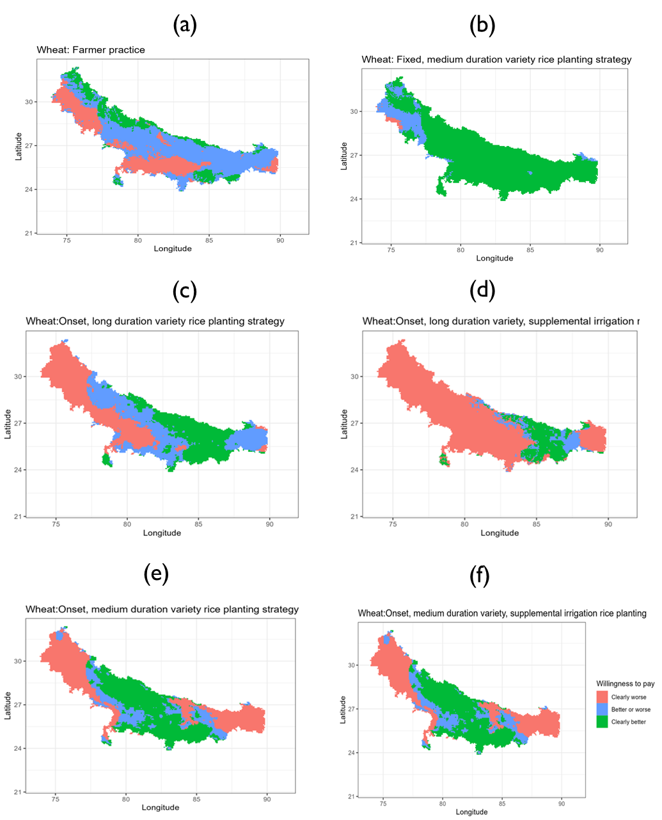

Figure 3: Willingness to pay (wheat yield t/ha) for the strategy against a fixed long duration variety reference strategy using second order stochastic dominance.

## 3.2. System-wide economic benefits for a risk averse farmer

The above yield-based risk assessment likely matter most to subsistence farmers. Most farmers in the IGP, however, sell some parts of their produce (Urfels et al. 2023). Fully evaluating the system level risks thus requires an economic evaluation across both crops. We first provide an overview of the revenue and associated risks, followed by a more profit-oriented analysis that includes partial costs incurred for irrigation as this is the only cost variable that varies across our scenarios.

### 3.2.1. System revenues

Table 5 shows the descriptive statistics for the willingness to pay bounds. Starting with the percentage of grid cells that would benefit from each of the scenarios as compared to the baseline, the WTP summary rows show that farmers’ practices is the worst performing strategy across the IGP (column 3) with 78% losing compared to the state recommended planting dates. This is followed by planting medium duration varieties at the monsoon onset with constrained irrigation (column 8) that results in 52% of cells clearly worse off than the baseline.

Table 5: Gross revenue WTP (thousand rupees/ha) bounds with fixed long as baseline

|  |  |  |  |  |  |  |  |
| --- | --- | --- | --- | --- | --- | --- | --- |
| Bound | Statistics | S0-S1 | S2-S1 | S3-S1 | S4-S1 | S5-S1 | S6-S1 |
| Upper bound | Mean | -23.99 | 34.99 | 8.37 | -14.67 | 14.30 | 1.49 |
| Std.Dev | 25.96 | 28.30 | 41.11 | 47.53 | 29.59 | 31.35 |
| Min | -144.09 | -28.54 | -84.72 | -125.24 | -64.90 | -89.49 |
| 10th percentile | -56.03 | -15.52 | -45.24 | -74.99 | -26.87 | -37.83 |
| 25th percentile | -39.27 | 22.03 | -19.37 | -51.28 | -4.45 | -19.90 |
| Median | -24.18 | 41.04 | 1.34 | -18.60 | 15.28 | -1.92 |
| 75th percentile | -12.33 | 56.10 | 39.14 | 20.11 | 36.06 | 25.19 |
| 90th percentile | 1.85 | 66.82 | 69.81 | 56.16 | 53.93 | 45.26 |
| Max | 87.55 | 91.16 | 96.57 | 86.07 | 132.20 | 108.48 |
| Lower bound | Mean | -73.43 | -1.39 | -18.36 | -43.68 | -16.67 | -28.19 |
| Std.Dev | 36.34 | 25.91 | 43.02 | 49.08 | 28.35 | 30.59 |
| Min | -177.76 | -59.94 | -123.07 | -139.93 | -119.55 | -151.45 |
| 10th percentile | -113.83 | -28.09 | -77.92 | -109.68 | -46.58 | -65.46 |
| 25th percentile | -94.35 | -20.99 | -53.41 | -86.66 | -30.70 | -43.60 |
| Median | -72.95 | -6.29 | -13.44 | -42.45 | -19.58 | -29.30 |
| 75th percentile | -56.20 | 16.31 | 10.49 | -3.30 | -1.85 | -11.96 |
| 90th percentile | -29.14 | 36.79 | 37.99 | 22.05 | 20.96 | 11.44 |
| Max | 83.40 | 69.35 | 87.03 | 76.56 | 113.90 | 83.34 |
| WTP summary | Clearly better (share) | 0.02 | 0.42 | 0.36 | 0.23 | 0.23 | 0.16 |
| Not clear (share) | 0.09 | 0.42 | 0.16 | 0.14 | 0.44 | 0.32 |
| Clearly worse (share) | 0.89 | 0.16 | 0.48 | 0.63 | 0.32 | 0.52 |
| Number of cells | 17456.00 | 17456.00 | 17456.00 | 17456.00 | 17456.00 | 17456.00 |

These results show that there is no one size fits all strategy and we further investigate the spatial structure to better understand the performance of different rice planting strategies across the IGP. Spatially, there are pockets for which a risk averse farmer would not switch to the recommended fixed date with long duration variety strategy especially in the central grid cells of Bihar. Again, the spatial structure of the results shows where, due to interannual weather risks, farmers may fare best to choose one specific strategy and where they might be similarly well off with more than strategy.

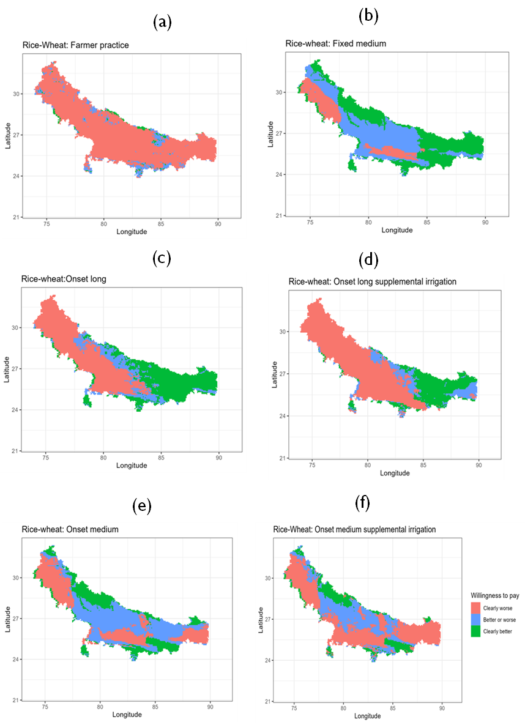

Figure 4: Spatial distribution of revenue WTP (where to target the scenarios)

### 3.2.2. System partial profits

When considering partial profits as incurred by the varying irrigation costs, the results again show that there is no one size fits all solution for the IGP with no single rice planting strategy outperforming others. Table 6 shows descriptive statistics for willingness to pay for partial profits (revenue-irrigation costs) for each of the planting date strategies as compared to fixed date-long duration rice variety strategy. As with productivity and revenue comparisons, farmer practice is a worse strategy for about 85% of the grid cells in IGP. None of the strategies dominate across the entire IGP as can be seen in figure 5.

Table 6: Partial profits WTP (thousand rupees/ha) descriptive statistics

|  |  |  |  |  |  |  |  |
| --- | --- | --- | --- | --- | --- | --- | --- |
| Bound | Statistics | S0-S1 | S2-S1 | S3-S1 | S4-S1 | S5-S1 | S6-S1 |
| Upper bound | Mean | -15.31 | 40.40 | 12.30 | 7.84 | 23.80 | 25.40 |
| Std.Dev | 22.82 | 28.98 | 42.88 | 46.27 | 31.34 | 34.62 |
| Min | -97.77 | -25.01 | -80.65 | -95.69 | -62.89 | -82.90 |
| 10th percentile | -36.40 | -10.73 | -42.52 | -49.44 | -21.58 | -17.54 |
| 25th percentile | -26.88 | 24.88 | -16.26 | -27.25 | 7.19 | -1.91 |
| Median | -18.74 | 47.15 | 2.00 | 1.43 | 24.04 | 23.22 |
| 75th percentile | -8.09 | 62.14 | 48.44 | 41.74 | 48.21 | 52.55 |
| 90th percentile | 6.10 | 72.21 | 77.33 | 79.22 | 63.93 | 74.15 |
| Max | 99.85 | 96.57 | 103.13 | 112.42 | 137.49 | 129.42 |
| Lower bound | Mean | -50.40 | 3.51 | -16.12 | -24.19 | -8.78 | -5.70 |
| Std.Dev | 26.63 | 25.83 | 44.08 | 47.57 | 28.33 | 32.81 |
| Min | -126.29 | -54.20 | -115.70 | -112.73 | -103.66 | -118.82 |
| 10th percentile | -79.57 | -23.43 | -73.37 | -82.82 | -38.10 | -47.72 |
| 25th percentile | -66.27 | -16.27 | -54.83 | -66.11 | -23.19 | -23.23 |
| Median | -52.75 | -0.94 | -13.87 | -28.33 | -12.87 | -6.43 |
| 75th percentile | -35.94 | 20.98 | 16.24 | 13.97 | 6.85 | 12.31 |
| 90th percentile | -21.19 | 41.44 | 44.49 | 43.67 | 29.05 | 36.92 |
| Max | 89.66 | 76.40 | 90.44 | 97.08 | 120.33 | 99.99 |
| WTP summary | Clearly better (share) | 0.02 | 0.49 | 0.37 | 0.31 | 0.32 | 0.38 |
| Not clear (share) | 0.13 | 0.37 | 0.18 | 0.21 | 0.48 | 0.35 |
| Clearly worse (share) | 0.85 | 0.14 | 0.45 | 0.48 | 0.21 | 0.27 |
| Number of cells | 17420.00 | 17420.00 | 17420.00 | 17420.00 | 17420.00 | 17420.00 |

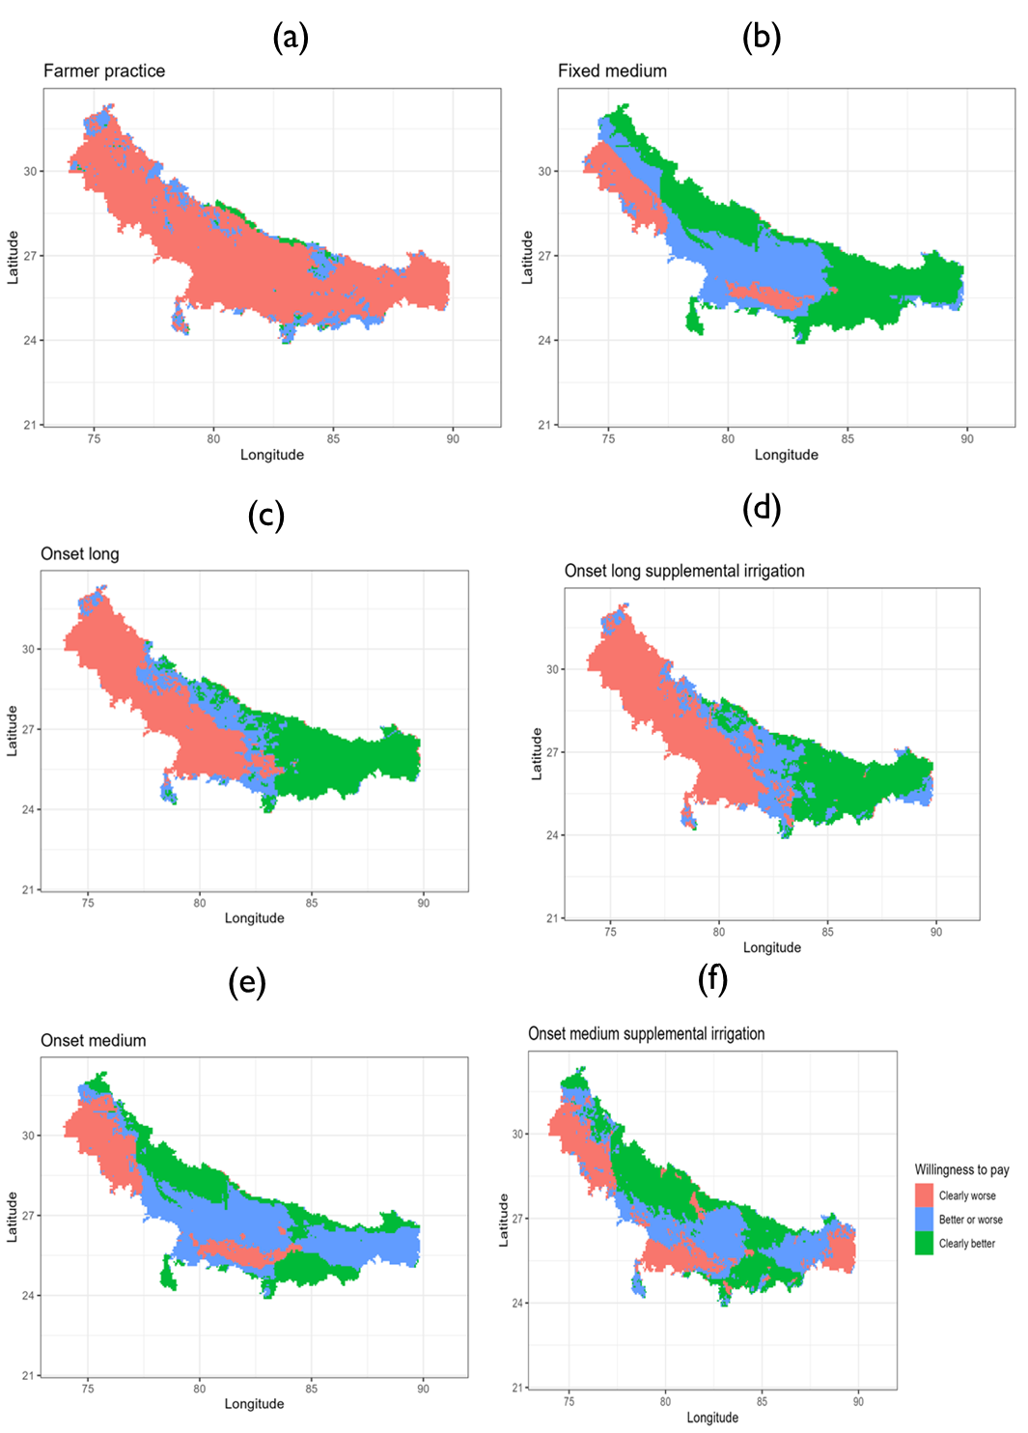

Figure 5: Spatial distribution of partial profit WTP (where to target the scenarios)

The preceding results have been interpreted on the basis of whether the strategy is better, worse or unclear based on whether the lower bound and upper bound are all positive, all negative or only lower bound is negative respectively. We use bounds in making this determination because in a distributional comparison of the adaptation options it is not possible to pin down one value. The use of willingness bounds however has another advantage beyond what we have shown with discrete choices, i.e., better, worse, unclear. It is that the magnitude of each of the bounds can give insights on downside and upside risk as well as the ambiguity of the adaptation option (the wider, the more ambiguous).

On average for example, on-set long strategy remains less risky and overall beneficial for farmers even if its partial returns are uniformly reduced by Rs. 12,300 per ha (equivalently about US$ 154 per ha at prevailing exchange rate of US$1=Rs. 80) by, for example, an increase in irrigation or a decrease in grain prices, both of which are common and likely scenarios. At the same time, it would require a uniform increase of US$ 201.5 for this strategy to become risk-free vis-a-vis the baseline strategy—fixed rice planting date with long duration variety strategy. Given that no average farmer or pixel exists for which these two average bounds would occur simultaneously, these numbers are best evaluated at pixel level as shown in figure 6. There are portions of the Eastern IGP where partial profits of onset long strategy are almost risk-free requiring reduction of profits of over US$1000 for any risk averse farmer to be indifferent to the baseline. These areas can be prioritized for the onset-long strategy. Of course, our profit data is only partial, and a full real-world recommendation should consider more comprehensive profit analyses - but even such partial analyses based on crop modelling results can provide decision makers with valuable ex-ante insights into the riskiness of adopting different climate adaptation strategies.

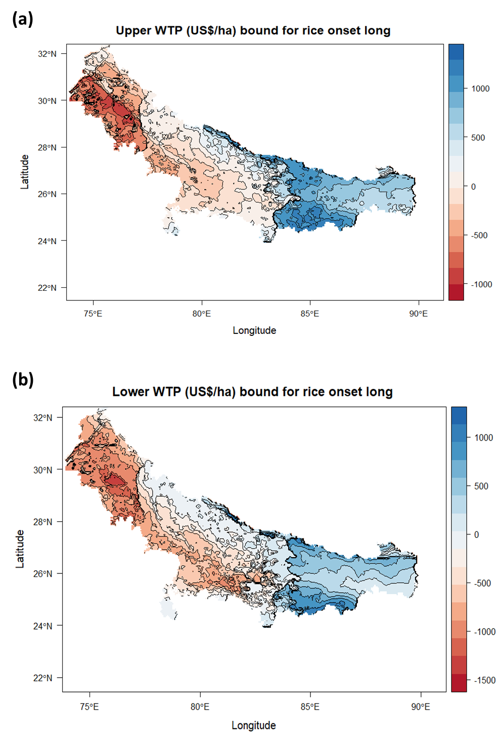

Figure 6: Quantitative analysis of willingness to pay bounds for onset-long strategy

# 4. Recommended rice planting date strategy per grid cell

Lastly, our risk-based evaluation approach allows us to compare all of the rice planting strategies against each other and identify which strategy performs clearly better and with less risks involved than any other strategy and where several competing strategies might result in similar economic benefits as well as risks. In other words, the above analysis has made binary or pairwise comparisons – while the most important question is: Which strategy should be recommended where? To derive this optimal scenario, we calculate the maximum upper bound WTP among the scenarios and the maximum lower WTP. If one single scenario clearly pay more and clearly induces less risks than the others, we select that scenario for that particular grid cell. As a result, Figure 7 shows the optimal rice planting date strategy. Importantly, in addition to the findings of Urfels et al. (2022), our framework shows that, for example, in parts of the Eastern Gangetic Plains providing only supplemental irrigation rather than full irrigation is economically beneficial from a risk perspective. While the same is true for some areas in the northern parts of the Middle and Western IGP – indicating that climatic and soil variability in the Northern and Southern parts of the Western and Middle IGP produce substantially different outcomes – but also indicating that in these areas multiple rice planting strategies perform equally well and farmers have more flexibility to choose amongst various options for similar results.

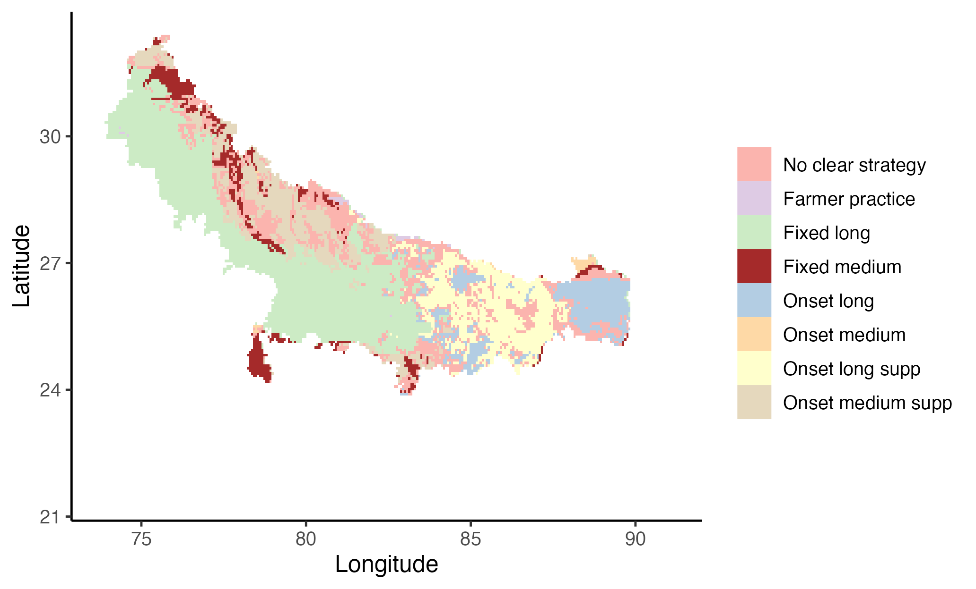

Figure 6: Optimal rice planting date strategy

# 5. Conclusion

We have shown in this article how a spatially explicit risk-assessment framework can provide evidences on how different agronomic climate adaptation strategies can be adequately evaluated for risk averse farmers. Our work builds on aand usesOur results for the IGP provide further evidence that early sowing of long duration rice is a suitable strategy for risk averse farmers of the rice-wheat rotation system in Bihar – while planting at state recommended dates and growing medium duration varieties is a better option in the Western and Middle IGP. Importantly, we also show that farmers in the Middle IGP have more flexibility to choose amongst competing options without jeopardizing incomes or increasing risks. With weather variability expected to further increase, our risk-assessment approach can provide a robust framework for evaluating various competing climate adaptation options for risk averse smallholder farmers that not only benefit from higher long term gains but also seek to minimize losses in any given year.

# Acknowledgements

This study was conducted as part of the Cereal Systems Initiative for South Asia (CSISA; [https://csisa.org/](https://csisa.org/" \t "_blank)) supported by the United States Agency for International Development (USAID) and Bill and Melinda Gates Foundation (BMGF). We thank Terrance Hurley for sharing the prototype Matlab code for the computational risk model. The content and opinions expressed in this paper are those of the authors and do not necessarily reflect the views of USAID or BMGF.

# Declaration of Competing Interest

The authors declare that they have no conflict of interest.

# References

Hurley, T., Koo, J., and Tesfaye, K. 2018. “Weather risk: how does it change the yield benefits of nitrogen fertilizer and improved maize varieties in sub-Saharan Africa?” *Agricultural Economics* 49: 711-723. Doi: 10.1111/agec.12454.

Ishtiaque, A., Singh, S., Lobell, D., Singh, B., Fishman, R., and Jain, M. 2022. “Prior crop season management constrains farmer adaptation to warming temperatures: Evidence from the Indo-Gangetic Plains.” *Science of the Total Environment* 807 (2). Doi: [https://doi.org/10.1016/j.scitotenv.2021.151671](https://doi.org/10.1016/j.scitotenv.2021.151671" \t "_blank" \o "Persistent link using digital object identifier).

Levy, H. 2016. “Stochastic Dominance: Investment Decision Making under Uncertainty.” Third Edition. Springer.

Levy, H. 1985. “Upper and lower bounds of put and call option value: Stochastic dominance approach”. The Journal of Finance XL (4). Doi: <https://doi.org/10.1111/j.1540-6261.1985.tb02372.x>.

Meyer, J. 1977. “Second degree stochastic dominance with respect to a function.” *International Economic Review* 18(2): 477-487. Doi: <https://doi.org/10.2307/2525760>.

Montes, C., Urfels, A., Han, E., and Balwinder-Singh. 2022. “Planting rice at monsoon onset could mitigate the impact of temperature stress on rice-wheat systems of Bihar, India.” *Atmosphere* 14(1), 40. Doi:  <https://doi.org/10.3390/atmos14010040>.

McDonald, A.J., Balwinder-Singh., Keil, A., Srivastava, A., Craufurd, P., Kishore, A., Kumar, V., Paudel, G., Singh, S., Singh, A.K., Sohane, R.K., and Malik, R.K. 2022. “Time management governs climate resilience and productivity in the coupled rice-wheat cropping systems of eastern India.” Nature Food. Doi: <https://doi.org/10.1038/s43016-022-00549-0>.

Markowitz, H.M. 1959. “Portfolio selection: Efficient diversification of investments”. Cowles Foundation for Research in Economics. Yale University. Url: <https://cowles.yale.edu/sites/default/files/2022-09/m16-all.pdf>.

Nalley, L.L., and Barkley, A.P. 2010. “Using Portfolio Theory to Enhance Wheat Yield Stability in Low-Income Nations: An Application in the Yaqui Valley of Northwestern Mexico.” *Journal of Agricultural and Resource Economics* 35(2): 334-347. Url: <https://www.jstor.org/stable/41960521>.

Newport, D., Lobell, D.B., Singh, B., Srivastiva, A., Rao, P., Umashaanker, M., Malik, R.K., McDonald, A., and Jain, M. 2020. “Factors Constraining Timely Sowing of Wheat as an Adaptation to Climate Change in Eastern India.” *Weather, Climate and Society* 515-528. Doi: [https://doi.org/10.1175/WCAS-D-19-0122.1](https://doi.org/10.1175/WCAS-D-19-0122.1" \t "_blank).

Suri, T. 2011. “Selection and Comparative Advantage in Technology Adoption.” *Econometrica* 79(1): 159-209. Doi:10.3982/ECTA7749.

Urfels, A., McDonald, A.J., Halsema, G., Struik, P.C., Kumar, P., Malik, R.K., Poonia, S.P., Singh, B., Singh, D.K., Singh, M., Krupnik, T.J. 2021. “Socio-ecological analysis of timely rice planting in Eastern India.” *Agronomy for Sustainable Development* 41: 14. Doi: <https://doi.org/10.1007/s13593-021-00668-1>.

Urfels, A., Montes, C., Balwinder-Singh, Halsema, G., Struik, P., Krupnik, T., and McDonald, J. 2022. “Climate adaptative rice planting strategies diverge across environmental gradients in the Indo-Gangetic Plains.” *Environmental Research Letters* 17: 124030. Doi: 10.1088/1748-9326/aca5a2.

Urfels, A., Mausch, K., Harris, D., McDonald, A.J., Kishore, A., Balwinder-Singh, Halsema, G., Struik, P.C., Craufurd, P., Foster, T., Singh, V., and Krupnik, T.J. 2023. “Farm size limits agriculture’s poverty reduction potential in Eastern India even with irrigation-led intensification”. *Agricultural Systems* 207: 103618. Doi: [https://doi.org/10.1016/j.agsy.2023.103618](https://doi.org/10.1016/j.agsy.2023.103618" \o "Persistent link using digital object identifier" \t "_blank).

Wang, X., Folberth, C., Skalsky, R., Wang, S., Chen, B., Liu, Y., Chen, J., and Balkovic, J. 2022. “Crop calendar optimization for climate change adaptation in rice-based multiple cropping systems of India and Bangladesh”. *Agricultural and Forest Meteorology* 315: 108830. Doi: [https://doi.org/10.1016/j.agrformet.2022.108830](https://doi.org/10.1016/j.agrformet.2022.108830" \o "Persistent link using digital object identifier" \t "_blank).











1. A similar computational willingness to pay bounds approach to second order stochastic dominance is used in the finance literature to evaluate put and call options (for details, see Levy 1985). [↑](#footnote-ref-2)
2. The gridded APSIM crop simulation model setup and results are available here: <https://git.wageningenur.nl/urfel001/igp-simulation-setup>. [↑](#footnote-ref-4)